**Internship Report - Day 3 - HTML Table/Lists Implementation**  
**Date:** 25th June, 2025

**Today's Focus:** Advanced HTML tables with nested lists

**Key Achievements:**  
✔ Built complex 6-column table with university data  
✔ Implemented nested ordered/unordered lists in cells  
✔ Applied custom styling (padding, centered alignment)  
✔ Used list-style modifications for cleaner presentation

**Challenges Solved:**  
• Fixed alignment issues with consistent CSS padding  
• Improved readability with selective bullet removal

**Code Snippets:**

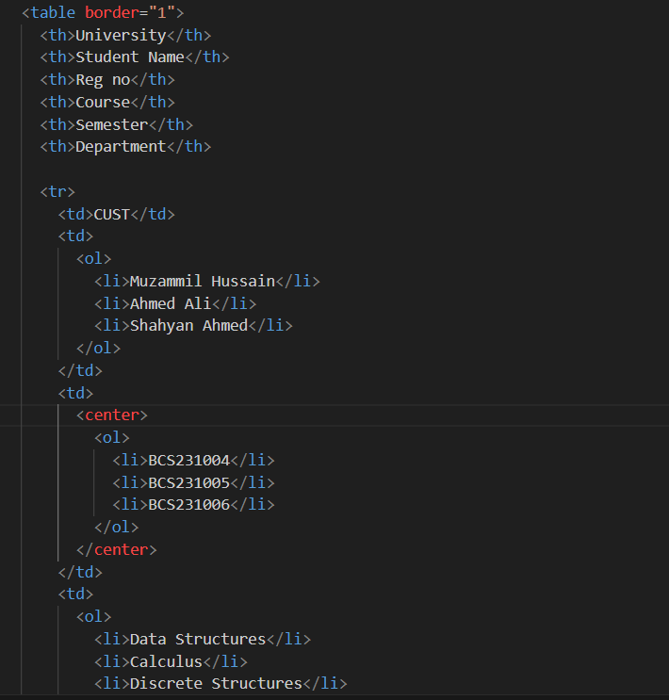

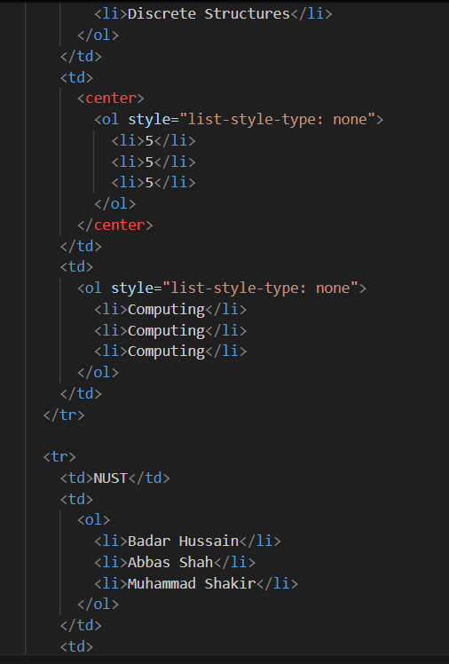 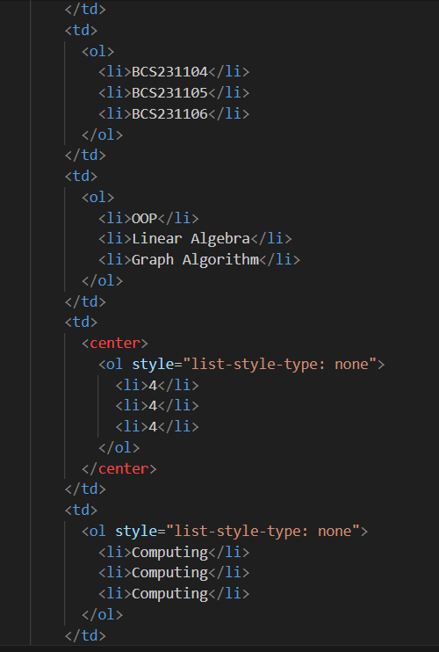

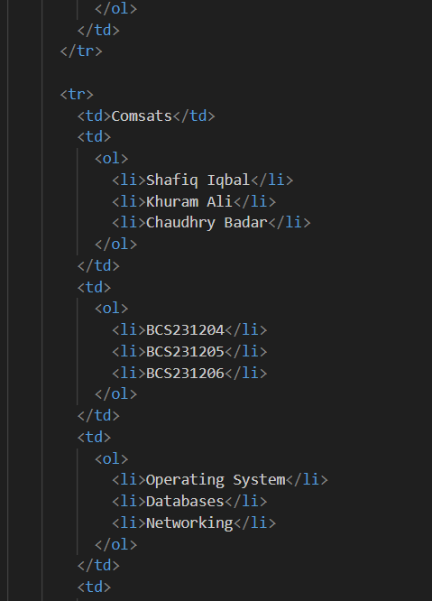 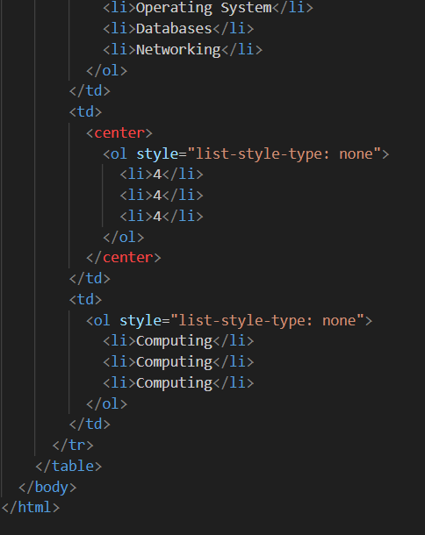

**Intern:** Muzammil Hussain Parvi

**Supervisor** Ali Hyder